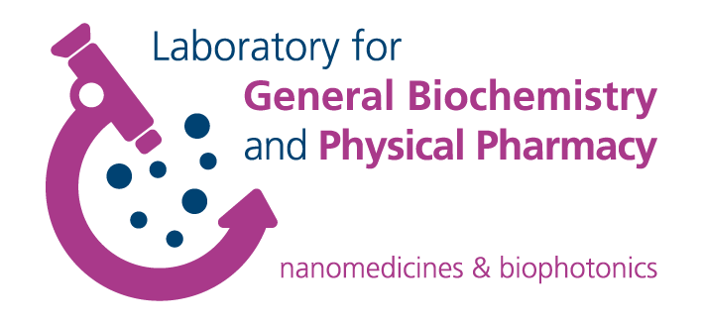

**FWO Research Consortium**

Nanomaterials for drug Delivery and in vivo Imaging

INVITATION

Symposium on drug delivery

*9:30am Understanding the structure and dynamics of the respiratory air-liquid interface: surfing the lung for diagnosis and therapy*

Prof. Jezus Perez-Gil, Complutense University, Madrid, Spain

*10.20am Optical manipulation of cells using light – poration, transfection and optogenetics*

Prof. Dr. Alexander Heisterkamp, Universitaet Hannover, Germany

*11:10am Designing AAVs for ocular gene therapy and gene delivery*

Prof. Deniz Dalkara, INSERM, Paris, France

**The seminar will take place on Friday June 16th 2017 in Seminar Room 2 at the faculty of pharmaceutical sciences, Ottergemse steenweg 460, 9000 Ghent, Belgium.**

**Contact** Prof. Kevin Braeckmans [Kevin.Braeckmans@UGent.be](mailto:Kevin.Braeckmans@UGent.be))

Prof. Katrien Remaut ([Katrien.Remaut@UGent.be](mailto:Katrien.Remaut@UGent.be))

Prof. Koen Raemdonck ([Koen.Raemdonck@UGent.be](mailto:Koen.Raemdonck@UGent.be))

Biography Jesus Perez-Gil

Prof. Jesus Perez-Gil obtained his PhD in Biology and Biochemistry by Complutense University in 1988. Later, he worked as Research Associate at the Biochemistry Dept. of Memorial University of Newfoundland, in St.John’s, Canada, and at the Max-Planck-Institut für Biophysikalische Chemie in Göttingen, Germany. In 1994 he became Associate Professor of Biochemistry at Complutense University, where he is currently Professor and Chair of the Biochemistry and Molecular Biology Department. In 2016, Prof. Perez-Gil has been elected President of the Spanish Biophysical Society and is currently Associate Editor of the journals *Biochimica et Biophysica Acta – Biomembranes* and *Chemistry and Physics of Lipids*, from Elsevier. Prof. Perez-Gil and his group at Complutense University have been investigating the molecular mechanisms of the pulmonary surfactant system for more than 25 years.

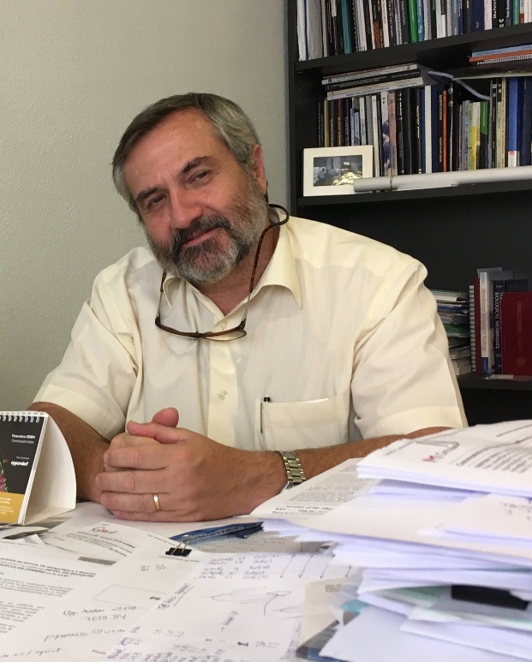

UNDERSTANDING THE STRUCTURE AND DYNAMICS OF THE RESPIRATORY AIR-LIQUID INTERFACE: SURFING THE LUNG FOR DIAGNOSIS AND THERAPY

Jesús Pérez-Gil

Dept. Biochemistry and Molecular Biology, Complutense University, Madrid, Spain

In order to maintain open the large surface that mammalian lungs expose to environment, the alveolar epithelium secretes a lipid-protein complex, the pulmonary surfactant, whose function is to form a surface active film that reduces surface tension and stabilizes the air-liquid interface along breathing dynamics. At the same time, surfactant integrates elements in charge of defending such large organism/environment interface against the entrance of pathogens. The proper structure, mechanical estability and biophysical performance of surfactant films strictly depends on the presence of two very hydrophobic proteins, SP-B and SP-C, whose lack or inactivation is associated with severe respiratory pathologies. Current models interpret surfactant homeostasis at the alveolar spaces as a consequence of the coordinated behavior of these two small polypeptides. The lecture will review current views on the structure-function determinants of SP-B and SP-C, the in vitro models that allow detecting alterations of their performance associated to respiratory problems and the development of new therapeutic materials based on pulmonary surfactant biophysics.

*Biography Alexander Heisterkamp*

Alexander Heisterkamp, PhD, is an expert in biomedical optics, with focus on nonlinear optics and the application of ultrashort laser pulses in medicine; especially nonlinear and linear imaging techniques, cell manipulation and laser-tissue interaction. He holds a professorship for Biophotonics at Leibniz Universitaet Hannover and is member of the scientific directorate at the Laser Zentrum Hannover



OPTICAL MANIPULATION OF CELLS USING LIGHT – PORATION, TRANSFECTION AND OPTOGENETICS

Alexander Heisterkamp

Institute of Quantum Optics, Leibniz Universitaet Hannover, Germany

Laser Zentrum Hannover, Hannover, Germany

Cellular modification or manipulations are key technologies in the field of molecular medicine and cell biology. Methods like transfection or transduction, siRNA screening and other methods are conventionally performed using viral, chemical or electrical approaches. Optical, especially laser based, techniques allow sterile and contact free handling and can easily be combined with fluorescence or cell sorting devices and have been a field of research for as long as over 30 years. In my talk I will cover a brief history of optical perforation techniques and thereby motivating different approaches like single cell transfection, shock-wave based or nanoparticle methods and other variants, showing some of our contributions to the field in more detail. As an outlook I will present possible directions and applications of the field of molecular medicine.

*Biography Deniz Dalkara*

Deniz Dalkara is a tenured researcher in INSERM, France and leads a team on gene therapies and animal models of neurodegenerative disease at the Vision Institute in Paris. She graduated from Middle East technical University with a B.S. degree in Biology in 2001. Afterwards, she obtained a masters degree in pharmacology and pharmacochemistry in Strasbourg, France where she later pursued a PhD degree in cellular and molecular aspects of biology. She was awarded the Biovalley PhD thesis for method of protein delivery developed during her graduate studies. Later on she conducted a postdoctoral fellowship in the laboratory of Ernst Babmerg at the Max Planck Institute of Biophysics before moving on to UC Berkeley to do a second post-doctoral training in 2007. At UC Berkeley, Dr Dalkara applied viral engineering principals to enhance AAV vectors for their application in retinal degenerative diseases. Her work includes molecular evolution and engineering of viral gene delivery vehicles and their application to develop innovative gene therapeutic strategies to combat blinding diseases of the retina. For her work in this area, she received Euretina Science and Medicine Innovation award in 2013 and she was selected Innovator under 35 –France by MIT Technology Review in 2014. Dr Dalkara received the Young Investigator award to start her group at the Vision Institute in Paris and has been carrying on her research activities in this research institute with a strong focus on translational research.

**C:\Users\kwullaer\AppData\Local\Microsoft\Windows\Temporary Internet Files\Content.Outlook\N0FTIXGR\Deniz2.tif**

DESIGNING AAVS FOR OCULAR GENE THERAPY AND GENE DELIVERY

Deniz Dalkara

Institut de la Vision, INSERM, Paris, France

The developments over the past decade in retinal gene therapy have shown that viral vectors can provide safe gene delivery to the eye’s retina and there is now hope that this treatment option can become a reality in clinical ophthalmology. Subretinal administration of recombinant adeno-associated virus (AAV) has already been demonstrated to be safe and effective in patients with type 2, Leber Congenital Amaurosis, suggesting that AAV-mediated retinal gene therapy may be successfully extended to other blinding conditions in the years to come. This will be possible thanks to the great flexibility of AAV as a vector platform as there are a large number of AAV variants with unique transduction characteristics useful for targeting different cell types in the retina. Cell types that can be transduced using AAVs include glia, epithelium and many types of neurons. Naturally occurring, rationally designed or “artificially evolved” AAV vectors are currently being utilized to target these cell types in the retina and to treat a variety of animal models of retinal disease. The continuous and inventive development of AAV vectors provides opportunities to overcome existing challenges in retinal gene therapy such as transfer of genes exceeding AAV’s cargo capacity, or the targeting of specific cells within the retina or transduction of photoreceptors following minimally invasive intravitreal injections. My talk will describe some of these recent developments in AAV technology, which will make it possible to advance the treatment of a wide range of blinding retinal conditions using gene therapy.