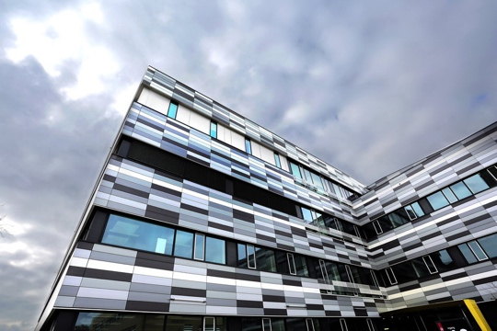 | 22th january 2019, 12.30  MRB2
Please join us for 1-hour scientific presentation for Cancer, inflammation and HIV researchers:

TGF beta: where cancer and HIV meet
by Rafick Seckaly of Case Western University's School of Medicine

Prof Seckaly is a key expert in T cell differentiation, immune exhaustion and vaccine response

The Case Comprehensive Cancer Center where Prof. Seckaly works is organized into seven interdisciplinary scientific programs that together include over 380 members across its affiliated institutions, Case Western Reserve University, University Hospitals Cleveland Medical Center, and Cleveland Clinic.
Program members work collaboratively within and across programs on a broad range of cancer-related topics. Each program leader strives to embrace these collaborations and advance research discoveries across the Center.

HCRC, Linos Vandekerckhove

