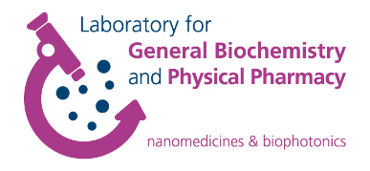
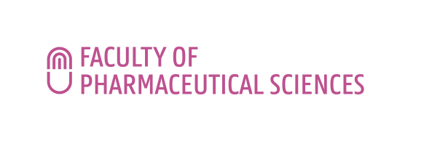
FWO Research Consortium
Nanomaterials for drug delivery and in vivo imaging

LECTURE INVITATION

A SUPER-RESOLVED VIEW ON NANOMEDICINE

Lorenzo Albertazzi^{1,2}
¹Eindhoven University of Technology, Eindhoven, The Netherlands
²Institute for Bioengineering of Catalonia, Barcelona, Spain;
E-mail: l.albertazzi@tue.nl

The lecture will take place on Thursday June 23rd 2022 at 2 pm in room 0.3 Alexander Fleming, Campus Heymans Faculty of Pharmaceutical Sciences, Ottergemsesteenweg 460, 9000 Ghent, Belgium.
Registration not required.

Contact
Prof. Kevin Braeckmans
Prof. Katrien Remaut

Abstract

Nanomaterials revolutionized the field of biomedicine introducing innovative approaches towards drug delivery, molecular imaging, regenerative medicine and biosensing. However, despite the large investments in nanotechnology the translation into clinical applications is still unsatisfactory. One of the main reasons is the lack of knowledge about the behavior of nanostructures in the biological environment that makes the rational design of effective materials extremely challenging. Here we will present the use of advanced microscopy techniques to understand the interactions of nanomaterials with living matter and to exploit this information to design novel devices for drug delivery.
We employ super-resolution microscopy to visualize and understand the molecular interactions of nanomaterials with their cellular targets at the single molecule level. Super resolution microscopy techniques such as stochastic optical reconstruction microscopy (STORM) and point accumulation for imaging in nanoscale topography (PAINT) offer nanometric resolution and multicolor ability, therefore they are ideal tools to study nano-sized multicomponent functional objects in vitro and in cells. This allows to get a closer “look” at the mechanisms of the key phenomena responsible for devices performance.
The fundamental knowledge acquired will pave the way towards the “microscopy-guided” design of novel nanomaterials for drug and gene delivery.

Short Bio

Lorenzo Albertazzi is an associate professor at the TU/e department of Biomedical Engineering leading the research group Nanoscopy for Nanomedicine. He is also Group Leader at the Institute of Bioengineering of Catalonia (IBEC) in Barcelona. For most of his career he has been jumping between Chemistry and Biophysics; in his research he now aims to combine both to achieve a molecular understanding of synthetic materials in the biological environment, using optical microscopy and nanoscopy. He obtained a MSc in Chemistry (2007) and a PhD in Biophysics (2011) from Scuola Normale Superiore (Pisa, Italy). He then joined Eindhoven University of Technology (TU/e, The Netherlands) as postdoctoral researcher. In 2014 he became a NWO VENI fellow. In 2015, he moved to Barcelona (Spain) to the Institute of Bioengineering of Catalonia (IBEC) to start the 'Nanoscopy for Nanomedicine' group that he currently leads. In 2018 he was appointed Associate Professor at the TU/e department of Biomedical Engineering where he obtained an ERC starting grant and a VIDI grant from NWO.

