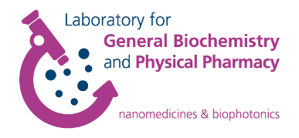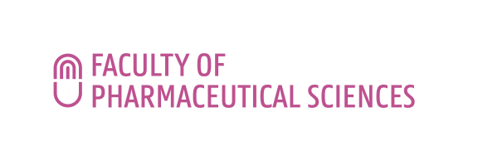**FWO Research Consortium**

Nanomaterials for drug delivery and in vivo imaging

LECTURE INVITATION

**Medical diagnosis and therapy assisted by plasmonic nanoparticles**

**Prof. Renato E. de Araujo**

**The lecture will take place on Wednesday September 14th 2022 at 14.00 h in seminar room Gertude Elion (0.2)**

**Faculty of Pharmaceutical Sciences, Ottergemsesteenweg 460, 9000 Ghent, Belgium.**

*Registration not required.*

**Contact**

Prof. Kevin Braeckmans

Plasmonic nanostructures are receiving attention as an important material for medical therapy and medical diagnosis. In particular, photoheating of metallic nanoparticles (NP) have been exploited in medical photothermal therapy. Light energy absorbed by the metallic NP can be converted to heat that dissipates to the environment, increasing the temperature of the NP surrounding medium, thereby potentially destroying cells or tissues. Various nanoparticle shapes, such as spheres, rods, shells and cages, show robust potential for thermal related therapy. Likewise, Photodynamic Therapy (PDT) has emerged as an important therapeutic option for numerous disease treatments. PDT combines photosensitizing drugs and light to induce selective damage on a target tissue or microorganism. Metallic NP could improve PDT action by enhancing the generation of oxygen singlet by a photosensitized molecule. On medical diagnosis, plasmonic nanoparticles have been used as platforms for biosensors. Several examples of nanostructured optical biosensors were demonstrated, aiming the identification of cancer-related biomolecules, Alzheimer disease, influenza virus, HIV-1 virus, Dengue virus, hepatitis B virus, and preeclampsia. In this presentation the light interaction of light with metallic nanoparticles will be described, and the use of plasmonic nanostructures on optical therapy and medical diagnosis will be reveled.

**Biography**

Dr. Renato de Araujo got his doctoral degree in physics at the Federal University of Pernambuco, Brazil (2001). During his Ph.D., Dr. de Araujo was involved in the study of nonlinear optical properties of organic materials. He did his postdoctoral training in the Robotic Institute at Carnegie Mellon University, performing research on advanced optical microscopy. In 2003, Dr. de Araujo worked as a research associate at Cedars Sinai Medical Center (Los Angeles). In 2006, he received the TWAS Young Scientists Award from the Academy of science for the developing world. In 2013, he got the SUS Science and Technology Award from the Brazilian ministry of health for his work on Dengue. Since 2006, Dr. de Araujo has been a professor at the Federal University of Pernambuco. His main research interests are biophotonics, nanotechnology, biosensors, optical spectroscopy and imaging.