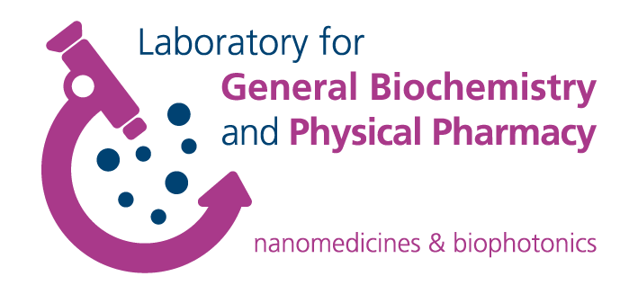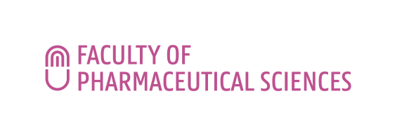**FWO Research Consortium**

Nanomaterials for drug delivery and in vivo imaging

LECTURE INVITATION

**Smart Cancer Nanomedicine**

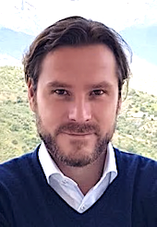

**Prof. Twan Lammers**

Department of Nanomedicine and Theranostics

Institute for Experimental Molecular Imaging

Center for Biohybrid Medical Systems

RWTH Aachen University Clinic

Forckenbeckstrase 55

52074 Aachen, Germany

Email: tlammers@ukaachen.de

Web: exmi.rwth-aachen.de/nano

**The lecture will take place on tuesday september 24th 2019 at 1.30 pm in Seminar Room 4**

**Faculty of Pharmaceutical Sciences, Ottergemsesteenweg 460, 9000 Ghent, Belgium.**

*Registration not required.*

**Contact**

Dr. Ine Lentacker

Prof. Stefaan De Smedt

**Smart Cancer Nanomedicine**

**Twan Lammers**

**Abstract**

Nanomedicines are 1-100(0) nm-sized carrier materials designed to improve the biodistribution and target site accumulation of systemically administered (chemo-) therapeutic drugs. By delivering drug molecules more efficiently to pathological sites, and by preventing them from accumulating in healthy tissues, nanomedicines are able to improve the balance between efficacy and toxicity. Nanomedicines rely on the Enhanced Permeability and Retention (EPR) effect for efficient target site accumulation, which is notoriously known to be highly variable, both in animal models and in patients. To tackle this high heterogeneity in EPR, and to improve the (pre-) clinical performance of cancer nanomedicines, we are working on “smart” systems and strategies to modulate and monitor tumor-targeted drug delivery. In the present lecture, several of these strategies will be highlighted, including pharmacological and physical modulation of tumor blood vessels and the microenvironment, and theranostic concepts for individualized and improved nanomedicine treatment.

**Biosketch**

Twan Lammersobtained a DSc degree in Radiation Oncology from Heidelberg University in 2008 and a PhD degree in Pharmaceutics from Utrecht University in 2009. In the same year, he started the Nanomedicine and Theranostics group at the Institute for Experimental Molecular Imaging at RWTH Aachen University Clinic. In 2014, he was promoted to full professor at the faculty of medicine at RWTH Aachen. He has published over 200 research articles and reviews, and has received several scholarships and awards. He is associate editor for Europe for the Journal of Controlled Release, and serves on the editorial board of multiple additional journals. His primary research interests include drug targeting to tumors, image-guided drug delivery and tumor-targeted combination therapies.

**References**

[1] Lammers et al, Cancer nanomedicine, Nat Rev Mater (2016)

[2] Golombek et al, Tumor targeting via EPR, Adv Drug Deliv Rev (2018)

[3] Lammers. Macro-Nanomedicine, J Control Release (2018)

[4] Sun et al, Nanomedicine in immuno-oncology, Chem Soc Rev (2019)

[5] Van der Meel et al, Smart cancer nanomedicine, Nat Nanotechnol (in press)