

**SEMINAR**

**Friday, October 6, 2017**

**15u30 – 16u30**

**seminar room MRB2 (Entrance 38), UZ Gent**

**“The making of T cells with unexpected reactivity”**

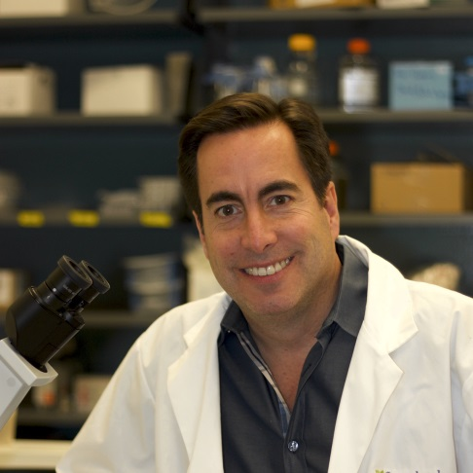

**Prof. Dr. Juan Carlos Zúñiga-Pflücker**

Professor & Chair

Department of Immunology, University of Toronto

Canada Research Chair in Developmental Immunology

Senior Scientist

Biological Sciences, Sunnybrook Research Institute

**Developed OP9-DL1 coculture system for generating T cells in vitro.**

Host : Prof. Dr. Tom Taghon